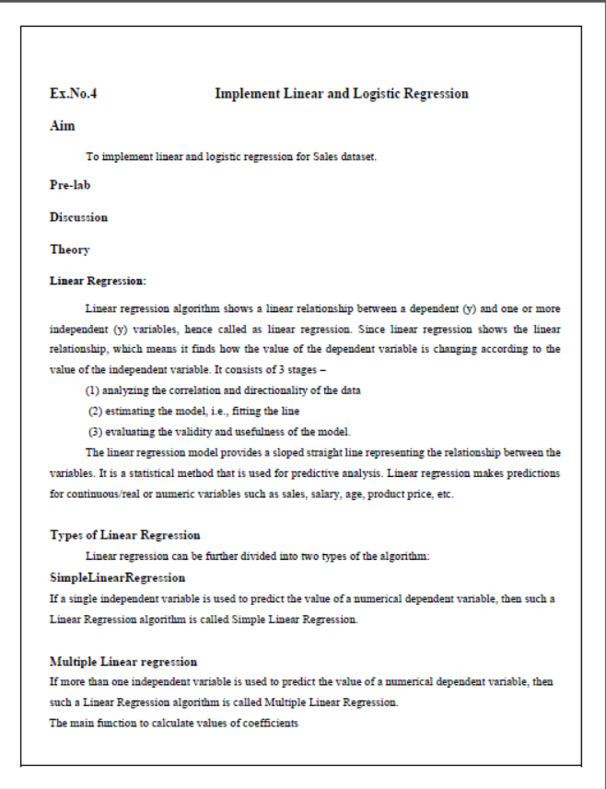

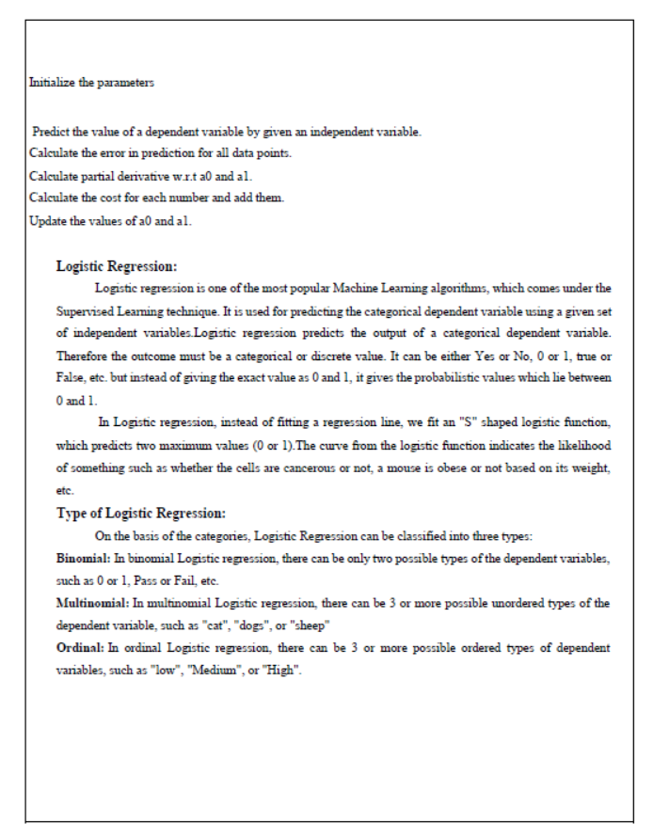

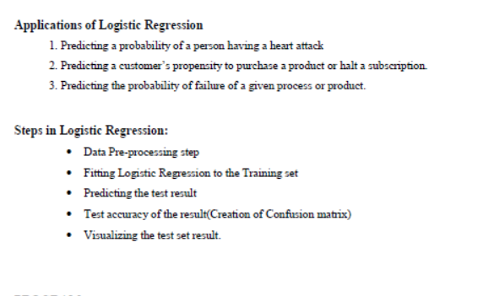

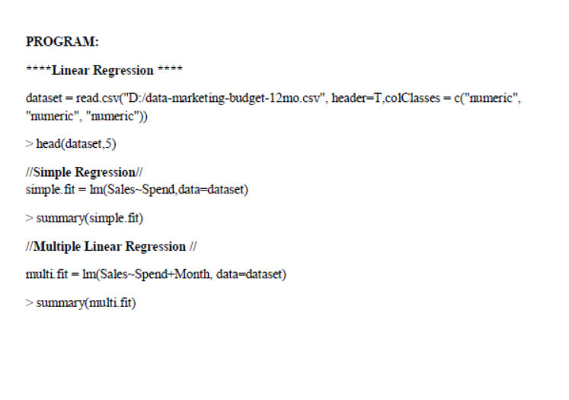

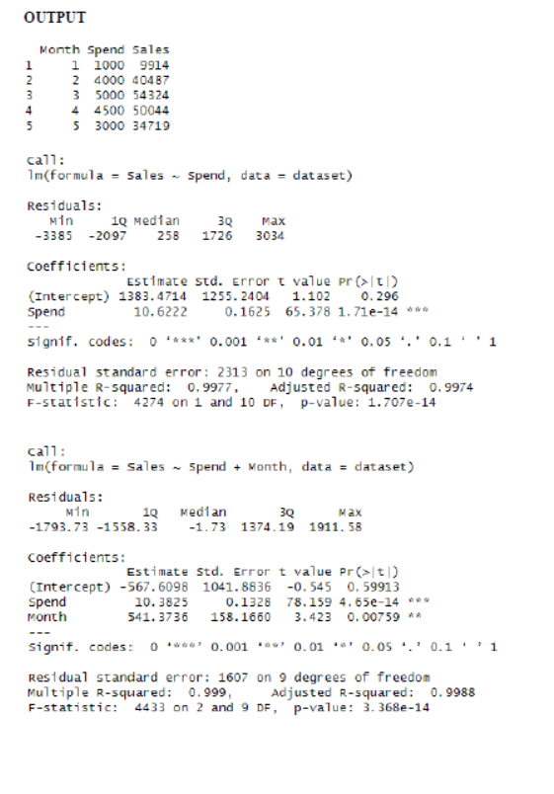

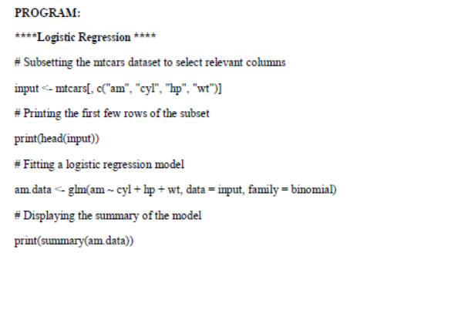

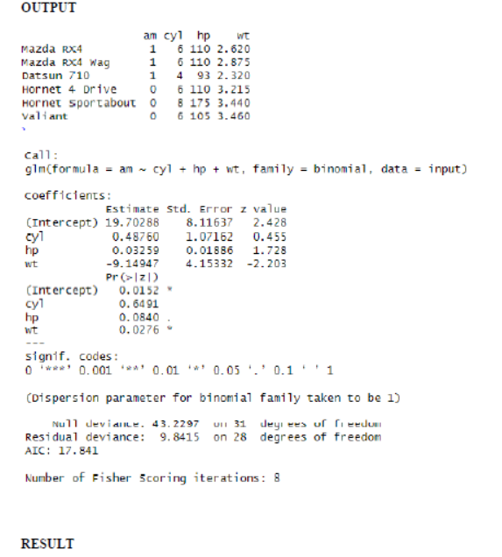

|  |  |
| --- | --- |
| Ex No:5 | Implementation of Decision tree classification technique |



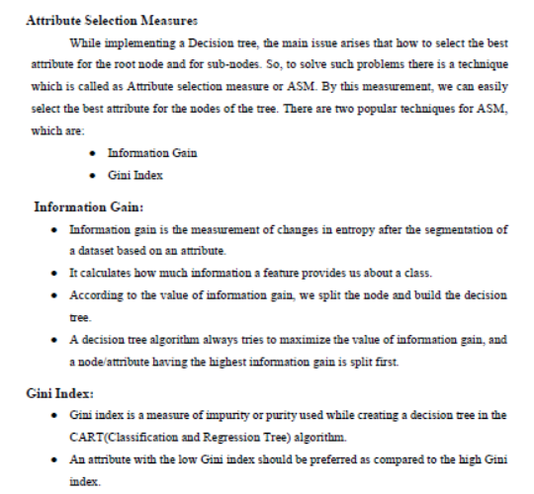

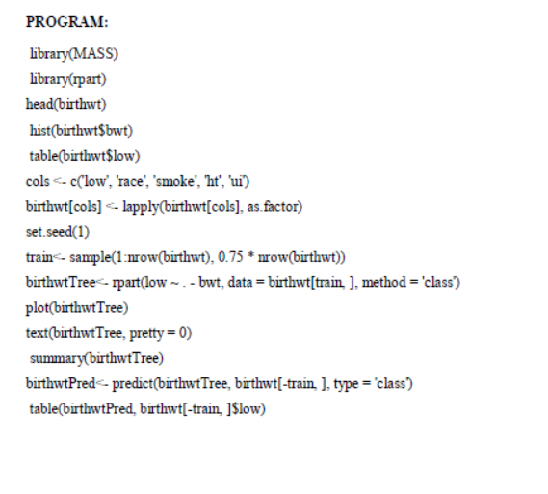

**OUTPUT**

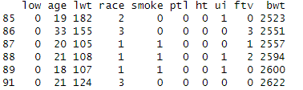



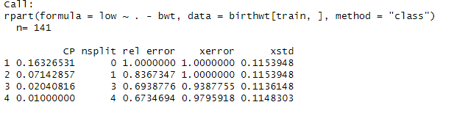

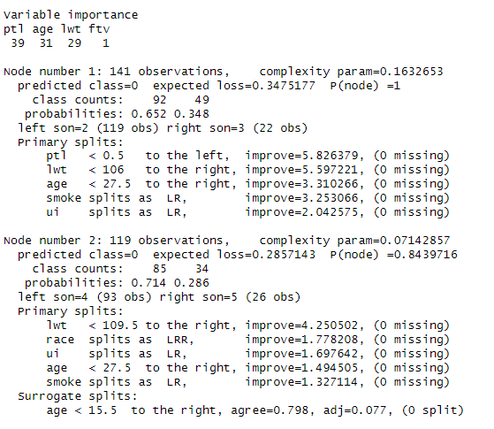

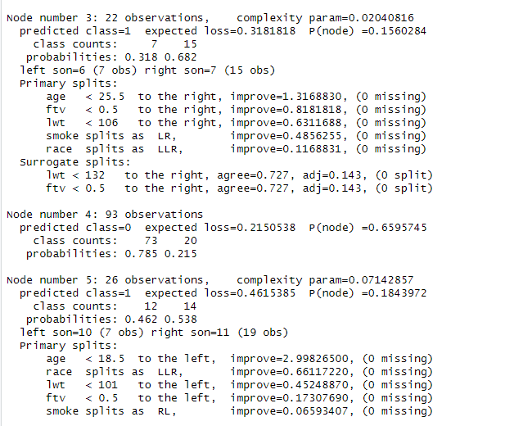

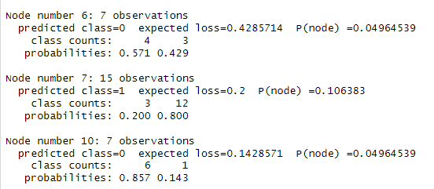

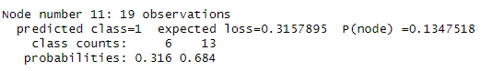



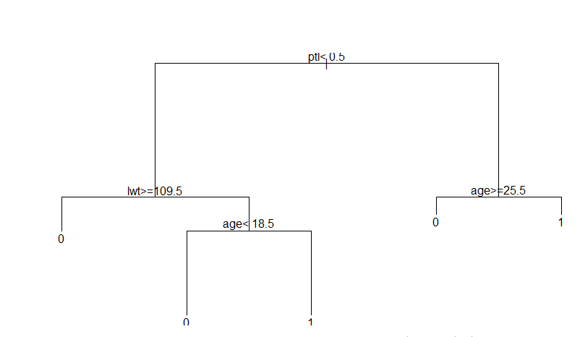

**Result**





**PROCEDURE**

**STEP 1** : INSTALL PACKAGE

install.packages("ggplot2")

**PROGRAM**

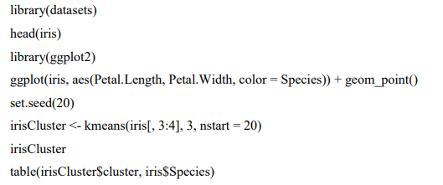

**OUTPUT**

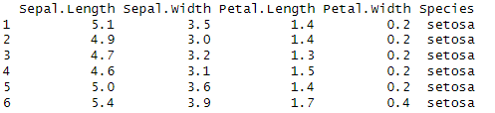

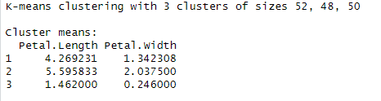

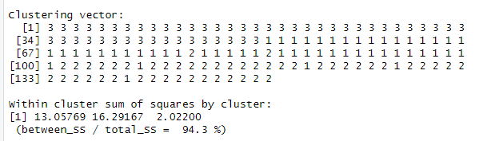

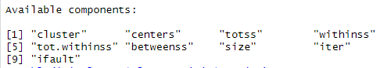

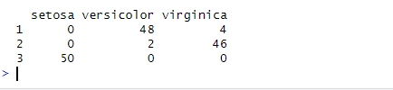

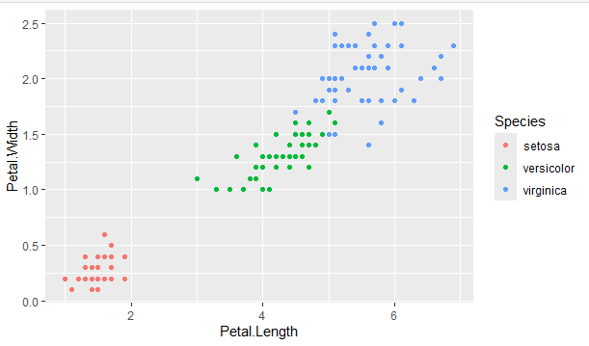

**RESULT**

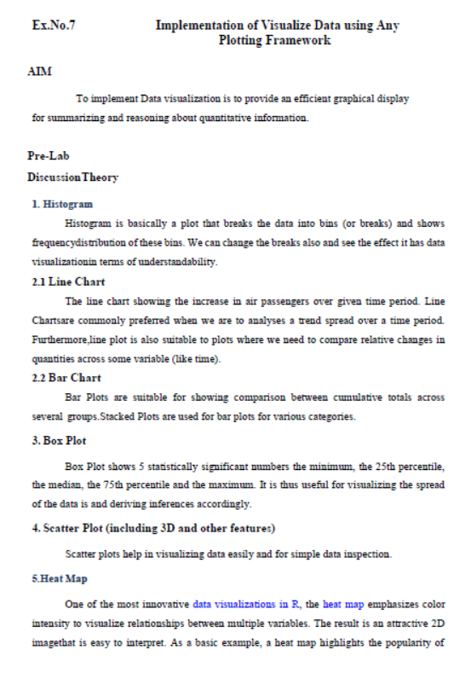

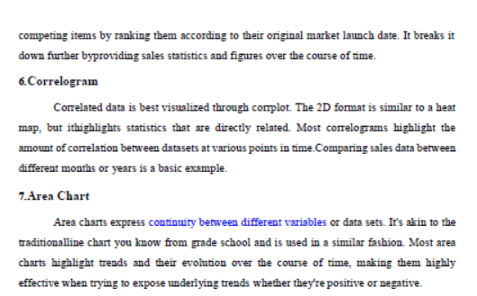

**PROCEDURE**

**Step 1: Download and Install Rtools**

1. Go to the Rtools download page: Rtools for Windows.
2. Download the version of Rtools that corresponds to your version of R. For example, if you're using R 4.x, you'll need Rtools 4.0 or higher.
3. Run the installer and follow the prompts. Make sure to check the option to add Rtools to your system PATH during installation (this will allow R to find Rtools automatically).

### Step 2: Verify Installation

Once Rtools is installed, you can verify it's correctly set up by running this in R:

Sys.which("make")

This should return the path to the make tool if Rtools is installed and accessible.

### Step 3: Install ggplot2 Again

After installing Rtools, you can proceed to install ggplot2:

install.packages("ggplot2")

Once the installation completes, you should be able to load ggplot2 with:

library(ggplot2)

### Step 4: Install the corrplot Package

Run this command to install the corrplot package:

install.packages("corrplot")

### Step 5: Load the Package

Once the installation is complete, load the package using:

library(corrplot)

### Use the corrplot Function

Now, you should be able to use the corrplot function to visualize your correlation matrix. For example:corrplot(corr_matrix)

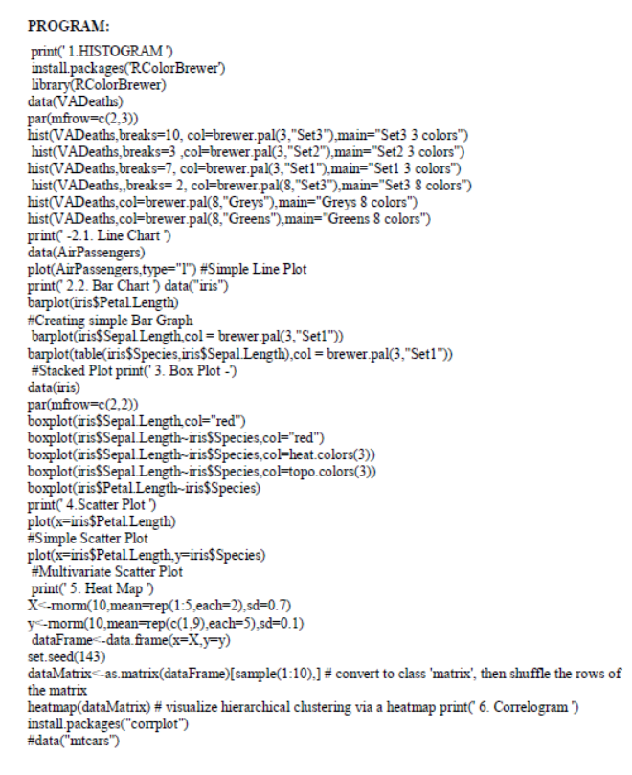

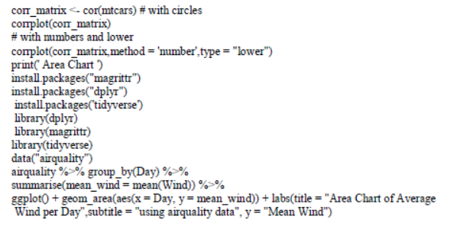

**OUTPUT**

**HISTOGRAM**

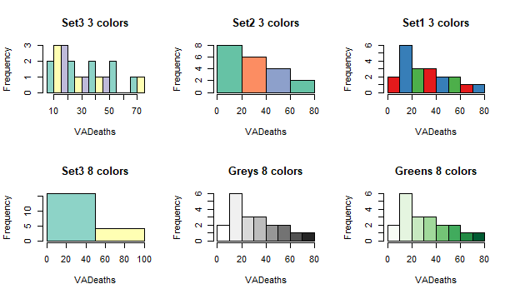

**LINE CHART**

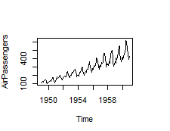

**BAR CHART**

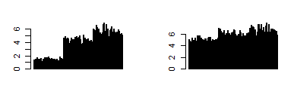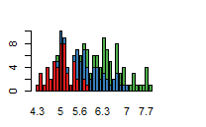  
**BOX PLOT**

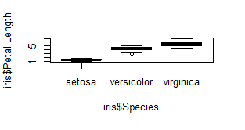

**SCATTER PLOT**

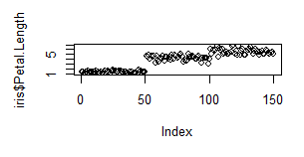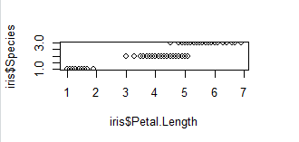

**HEAT MAP**

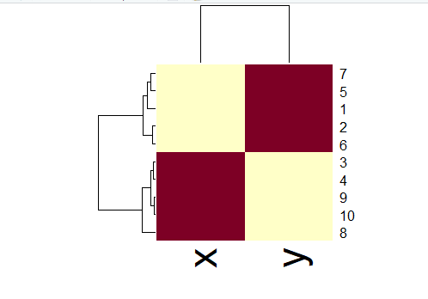

**CORRELOGRAM**

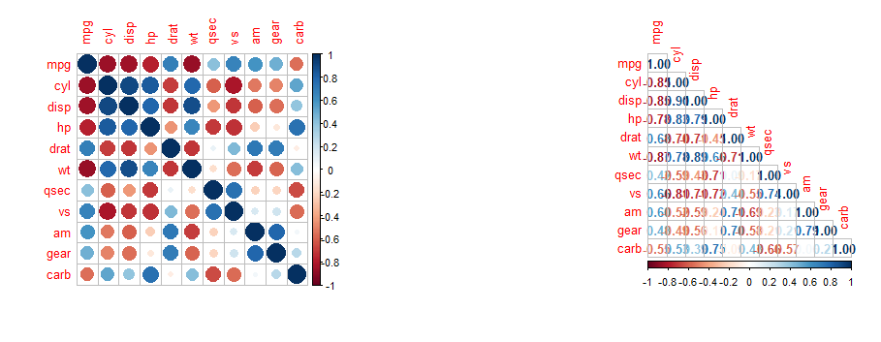

**AREA CHART**

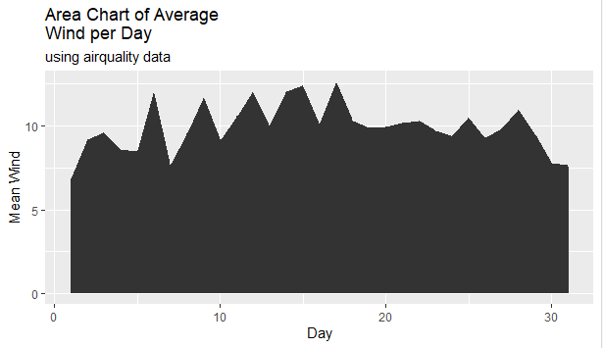

RESULT